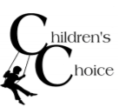
This Month’s Theme:
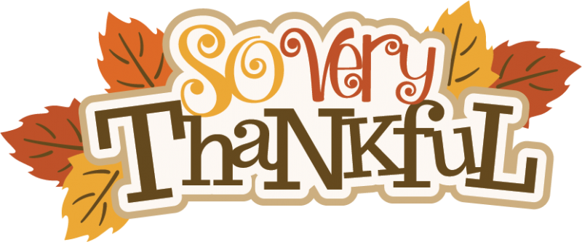

Monday | Tuesday | Wednesday | Thursday | Friday
30  All Fun and Games with Brianna-Capture the Flag  Thank You Notes with Linnea  Is That a T-Shirt with Monique- Pillow Covers!  Recycled Tower with Cindra | 31  How to Solve a Rubik’s Cube with Caleb- Introduction  Cops and Robbers with Cindra  Recycled Art with Savana- Nature Walk  DIY Bird Feeders with Monique | 1  Keep it Clean with George-Bottle Jellyfish  Acrostic Poems with Brianna  Pumpkin STEM with Linnea- Pumpkin Towers  Indoor Mini-Golf with Ashleigh | 2  Comic Books with Wes-Design!  Pom-Pom Pinecone with George  Puppet Theater with Lena- Setting  Chuck the Turkey with Savana | 3  Thank-fall for Leaves with Cindra- Leaf Walk  Musical Chairs with Brianna  Fall Pictionary with Lena  One Handed Hot Potato with Caleb
6  All Fun and Games with Brianna-Knockout  Stuff the Turkey with Linnea  Is That a T-Shirt with Monique- Build a Bag!  Wind Chimes with George | 7  How to Solve a Rubik’s Cube with Caleb- Solving The 1st Side  Shake, Tail Feathers with Lena  Recycled Art with Savana- Comparing Components  Thankful Cards with Ashleigh | 8  Keep it Clean with George-Sea Turtles  Paper Football with Caleb  Pumpkin STEM with Linnea- Candy Corn on the Cob  Turkey Tag with Lena | 9  Comic Books with Wes-Story! Gratitude Scavenger Hunt with Linnea  Puppet Theater with Lena- Characters  Hoop Through with George | 10  Thank-Fall for Leaves with Cindra-Collage  Who am I with Monique  Leaf Rubbings with Savana  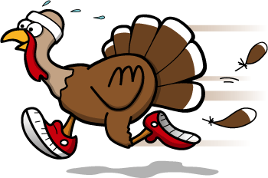  Turkey Trot!
13  All Fun and Games with Brianna-  Jeopardy  Gratitude Straws with Linnea  Is That a T-Shirt with Monique- Headbands  On the Go Tic-Tac-Toe with Cindra | 14  How to Solve a Rubik’s Cube with Caleb- Solving the 2nd Layer  Garbage Ball with Cindra  Recycled Art with Savana- Creations!  Plant Me! with Monique | 15  Keep it Clean with George-Tiny Houses  Wreath of Thanks with Brianna  Pumpkin STEM with Linnea- The Great Pumpkin Tower  Penguin Waddle Races with Ashleigh | 16  Tape Obstacle Course with Monique  Comic Books with Wes-Color!  Scribble Mosaic with Caleb  Puppet Theater with Lena- Dress Rehearsal | 17  Mime Partner with George  Thank-fall for Leaves with Cindra- Leaf Color Change!  Roll A Turkey with Lena  Blanket Race with Caleb
Parent Teacher Conferences, on the 20th and 21st. Children’s Choice is open at North Star Elementary school from 7am-6pm! Make sure to pack a lunch! |  | Start of Thanksgiving Break on the 22nd. Children’s Choice is open at North Star Elementary school from 7am-6pm! Make sure to pack at lunch! | Holiday on the 23rd and 24th.  Children’s Choice is Closed!  Enjoy the Holiday!
Double Eagle Elementary Calendar of Activities!
Enrichment Classes: Monday- Cooking (3-5), Art (K-2) Tuesday- I Love Literacy, Sports (3-5), Battle of the Books (4-5) Wednesday- Games (K-2) Thursday- Wrinkle Writing (3-5), Student Council Friday- No Classes!

Enrichment Classes: Monday- Cooking (3-5), Art (K-2) Tuesday- I Love Literacy, Sports (3-5), Battle of the Books (4-5) Wednesday- Games (K-2) Thursday- Wrinkle Writing (3-5), Student Council Friday- No Classes!

