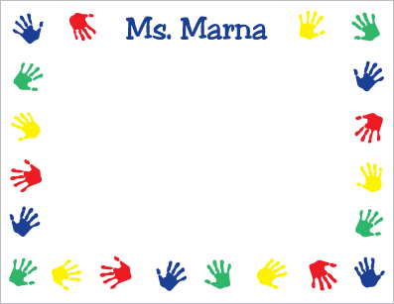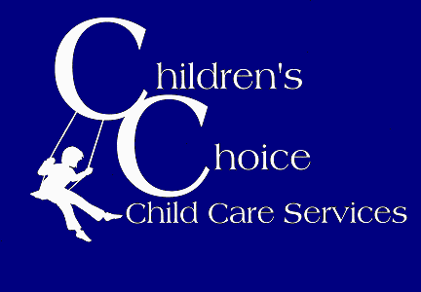

**November News at osuna**

**Conferences**

Due to parent-teacher conferences, there will be no school Monday, November 20th through Wednesday, November 22nd. Children’s Choice will be open at Hubert Humphrey from 7 AM to 6 PM. Please sign up in advance if you plan to attend, and bring a sack lunch that does not require microwave or refrigeration. Breakfast and snacks will be served. **Children’s Choice will be closed Thursday, November 23rd and Friday, November 24th.** Enjoy the holiday with your family!

**CC Around the World**

Our theme for November is “CC Around the World!” We have exciting activities planned that incorporate traditions from countries and cultures across the globe. The kids can look forward to learning how to use chopsticks, making sugar skulls for Dia de los Muertos, and creating their own Carnaval parade floats! If your family would like to share their favorite food, games, or traditions with the children, please speak with the staff. ☺

**Field Trips**

Our field trips this month will be to Outpost Ice Arena on Friday, November 3rd and the Indian Pueblo Cultural Center on Friday, October 17th. If you need your child to stay back from any field trip, please add them to the stay back list on the parent table. Interested in chaperoning a field

trip? We would love to have you, please speak with any of the staff! ☺

**Children’s Choice**

Volume 1, Issue 2

November 2017

☺Please call us at 382-1815 if your child won’t be attending Children’s Choice for the day.

**Ad**

**Reminders:**

☺If your child needs to take medication while at Children’s Choice, please speak with the staff so we can store and administer it safely.

☺ **CC is open at Hubert Humphrey Nov. 20th-22nd for conferences. Sign up in advance & don’t forget a lunch! CC will be closed Nov. 23rd-24th.**

**Helpful Information**

Site Phone: 382-1815

Office Phone: 296-2880

Email: osuna@childrens-choice.org

**Financial Assistance Available: 841-4800**

**Halloween Fun**

October was full of fun activities leading up to Halloween! One of our favorites was mummy races outside in the grassy field, where we worked together to cover our teammates head to toe in paper and then navigated obstacles dressed as mummies. The kids also enjoyed making their own edible haunted houses out of goodies such as graham crackers, raisins, and marshmallows. Stay tuned for one of our favorite CC traditions in November – the Turkey Trot!

