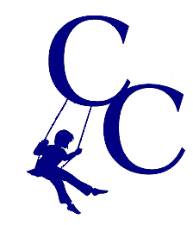
Review Circle Member Preparation Form

Round 1: What I have done well: Please think about what you would like to say and write your notes here:

What do I do well in terms of my relationships?
- What do I do well in terms of my contributions to the environment?
- What do I do well in terms of facilitating positive, enriching, responsive, and/or novel experiences?

Round 2: What I could do better: Please think about what you will say and write your notes here:

What could I do better in terms of my relationships?
- What could I do better in terms of my contributions to the environment?
- What could I do better in terms of facilitating positive, enriching, responsive, and/or novel experiences?

Round 3: Exploration of Improvement Areas: What areas or dimensions need improvement (not how we want this to be improved). Examples may be time management, communication, relationships, attitude, etc. This will be based on all the information provided in the previous rounds and will be consented to by the circle. This work will/can be done during the circle.

Round 4: Exploration of Improvement Plan: The next part will be to brainstorm action step ideas. How would we like to see improvements in those areas? These must include terms and measurements. This work can/will be done during the circle.

